NAME: RAMYA RAMESH

USN: 1BM19CS227

**PROGRAM 5 = FLIGHT DATABASE**

create database flight;

use flight;

create table flights(

flno INT,

flfrom VARCHAR(20) NOT NULL,

flto VARCHAR(20) NOT NULL,

distance INT,

departs TIMESTAMP,

arrives TIMESTAMP,

price REAL,

PRIMARY KEY (flno));

desc flights;

create table aircraft(

aid INT,

aname VARCHAR(20),

cruisingrange INT,

PRIMARY KEY (aid));

desc aircraft;

create table employees(

eid INT,

ename VARCHAR(20),

salary REAL,

PRIMARY KEY (eid));

desc employees;

create table certified(

eid INT,

aid INT,

PRIMARY KEY (eid,aid),

FOREIGN KEY (eid) REFERENCES employees(eid),

FOREIGN KEY (aid) REFERENCES aircraft(aid));

desc certified;

insert into flights values(101,'Bangalore','Delhi',2500,'2005-05-13 07:15:31','2005-05-13 17:15:31',5000);

insert into flights values(102,'Bangalore','Lucknow',3000,'2005-05-13 07:15:31','2005-05-13 11:15:31',6000);

insert into flights values(103,'Lucknow','Delhi',500,'2005-05-13 12:15:31','2005-05-13 17:15:31',3000);

insert into flights values(107,'Bangalore','Frankfurt',8000,'2005-05-13 07:15:31','2005-05-13 22:15:31',60000);

insert into flights values(104,'Bangalore','Frankfurt',8500,'2005-05-13 07:15:31','2005-05-13 23:15:31',75000);

insert into flights values(105,'Kolkata','Delhi',3400,'2005-05-13 07:15:31','2005-05-13 09:15:31',7000);

commit;

select * from flights;

insert into aircraft values(101,'747',3000);

insert into aircraft values(102,'Boeing',900);

insert into aircraft values(103,'647',800);

insert into aircraft values(104,'Dreamliner',10000);

insert into aircraft values(105,'Boeing',3500);

insert into aircraft values(106,'707',1500);

insert into aircraft values(107,'Dream',120000);

commit;

select * from aircraft;

insert into employees values(701,'A',50000);

insert into employees values(702,'B',100000);

insert into employees values(703,'C',150000);

insert into employees values(704,'D',90000);

insert into employees values(705,'E',40000);

insert into employees values(706,'F',60000);

insert into employees values(707,'G',90000);

commit;

select * from employees;

insert into certified values(701,101);

insert into certified values(701,102);

insert into certified values(701,106);

insert into certified values(701,105);

insert into certified values(702,104);

insert into certified values(703,104);

insert into certified values(704,104);

insert into certified values(702,107);

insert into certified values(703,107);

insert into certified values(704,107);

insert into certified values(702,101);

insert into certified values(703,105);

insert into certified values(704,105);

insert into certified values(705,103);

commit;

select * from certified;

TABLES:

1. flights

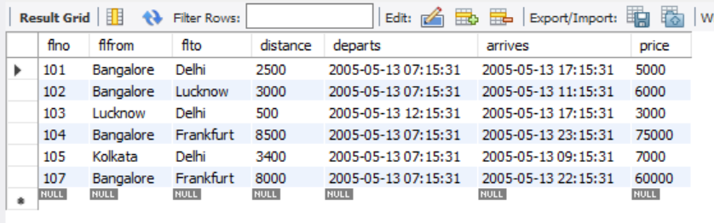

1. aircraft

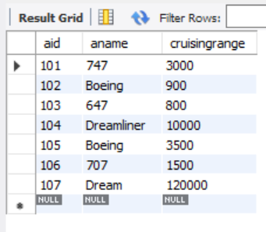

1. employees

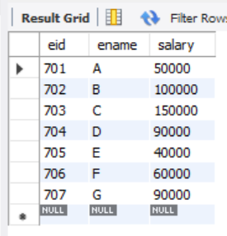

1. certified

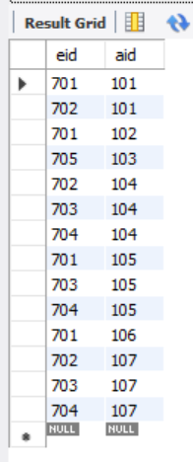

QUERIES:

1. Find the names of aircraft such that all pilots certified to operate them have salaries more than Rs.80,000.

SELECT DISTINCT a.aname

FROM aircraft a,certified c,employees e

WHERE a.aid=c.aid

AND c.eid=e.eid

AND NOT EXISTS

(SELECT * FROM employees e1

WHERE e1.eid=e.eid

AND e1.salary<80000);

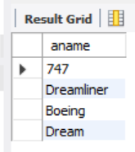

1. For each pilot who is certified for more than three aircrafts, find the eid and the maximum cruisingrange of the aircraft for which she or he is certified.

SELECT c.eid,MAX(cruisingrange)

FROM certified c,aircraft a

WHERE c.aid=a.aid

GROUP BY c.eid

HAVING COUNT(*)>3;

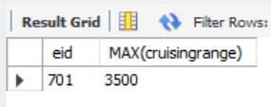

1. Find the names of pilots whose salary is less than the price of the cheapest route from Bengaluru to Frankfurt.

SELECT DISTINCT e.ename

FROM employees e

WHERE e.salary<

(SELECT MIN(f.price)

FROM flights f

WHERE f.flfrom='Bangalore'

AND f.flto='Frankfurt');

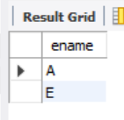

1. For all aircraft with cruisingrange over 1000 Kms, find the name of the aircraft and the average salary of all pilots certified for this aircraft.

SELECT a.aname,AVG(e.salary)

FROM aircraft a,certified c,employees e

WHERE a.aid=c.aid

AND c.eid=e.eid

AND a.cruisingrange>1000

GROUP BY a.aid,a.aname;

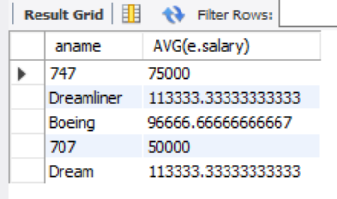

1. Find the names of pilots certified for some Boeing aircraft.

SELECT distinct e.ename

FROM employees e,aircraft a,certified c

WHERE e.eid=c.eid

AND c.aid=a.aid

AND a.aname='Boeing';

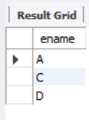

1. Find the aids of all aircraft that can be used on routes from Bengaluru to Frankfurt.

SELECT a.aid

FROM aircraft a

WHERE a.cruisingrange>

(SELECT MIN(f.distance)

FROM flights f

WHERE f.flfrom='Bangalore'

AND f.flto='Frankfurt');

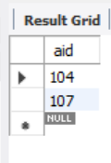

1. A customer wants to travel from Bangalore to Delhi with no more than two changes of flight. List the choice of departure times from Bangalore if the customer wants to arrive in Delhi by 6 p.m.

SELECT f.departs

FROM flights f

WHERE f.flno IN ((SELECT f0.flno

FROM flights f0

WHERE f0.flfrom = 'Bangalore' AND f0.flto = 'Delhi'

AND extract(hour from f0.arrives) < 18 )

UNION

(SELECT f0.flno

FROM flights f0, flights f1

WHERE f0.flfrom = 'Bangalore' AND f0.flto <> 'Delhi'

AND f0.flto = f1.flfrom AND f1.flto = 'Delhi'

AND f1.departs > f0.arrives

AND extract(hour from f1.arrives) < 18)

UNION

(SELECT f0.flno

FROM flights f0, flights f1, flights f2

WHERE f0.flfrom = 'Bangalore'

AND f0.flto = f1.flfrom

AND f1.flto = f2.flfrom

AND f2.flto = 'Delhi'

AND f0.flto <> 'Delhi'

AND f1.flto <> 'Delhi'

AND f1.departs > f0.arrives

AND f2.departs > f1.arrives

AND extract(hour from f2.arrives) < 18));

